Chuckles Day Care Wales Ltd
Safeguarding Policy (1/2)

We all have a responsibility for safeguarding children. All team members and individuals who come into contact with children and families as part of their work should be alert to possible signs of abuse (see separate procedure for what to do if you suspect abuse)

“Experience and consultation with children, shows that they will talk about their concerns and problems to people they feel they can trust and feel comfortable with.”

Child protection is part of safeguarding and promoting welfare. This refers to the activity which is undertaken to protect specific children who are suffering or are at risk of suffering significant harm as a result of abuse or neglect.

Safeguarding covers more than the contribution made to child protection in relation to individual children, it also includes
- The safe recruitment, supervision, training and management of employees.
- How team members manage children’s behavior
- Health and safety
- Bullying
- Arrangements for meeting the needs of children with medical conditions
- Safeguarding issues that are specific to the local area or population such as drugs and substance misuse

Our aims
- To ensure that appropriate procedures and practices are in place to safeguard and promote the welfare of children, and respond to immediate concerns, bringing matter requiring attention to the relevant authorities.
- That all team members complete a Safeguarding Training Course delivered by an approved trainer and then regular refreshers in house so that they have a good understanding of safeguarding concerns, including potential abuse and neglect of children.
- To ensure that all team members understand the importance of safeguarding children and that this is reflected both individual practice and in our policies and procedures.
- Create an environment that encourages children to develop a positive self-image regardless of race, religion, culture, sexuality, disability, gender or background, where everyone feels valued.

How this will be achieved in our daily practices:
- Establishing a safe and healthy childcare environment
- Maintain adult:child ratios stipulated by CIW requirements at all times
- Inform parents of our safeguarding procedures within the parent information pack
- Ensure that we have a designated area available to have confidential meetings and conversations with parents where we will not be overheard or disturbed. This is currently – The main office or if this is being used the out building that houses the gym.
- Establishing routines for childcare
- Monitor children’s attendance and keep in contact with families if they are absent for long periods of time
- Manage children’s behaviour in a positive way.
- Ensure we follow Inclusion and Anti – bias practices
- Ensure that no team member is left alone with children for long periods of time and that volunteers and placements are never left alone.
- Ensure that there is a Safeguarding policy in place that is updated regularly and that all team members are aware of the procedures within it.
- Restrict the use of mobile phones to the team rest room
- Permit the taking of photographs on the designated nursery equipment only and ensure all staff are aware it is not permitted to leave the premises.

Protection Risk Table

This table can be used to determine if a referral needs to be made or if another could be taken to give support and advice.

PROTECTION  (Risk) | Critical interventions and immediate action
PROTECTION  (Risk) | Formal safeguarding procedures
PREVENTION  (Needs) | Referral for assessment of care and support needs
PREVENTION  (Needs) | Management at agency/local level
PREVENTION  (Needs) | Information, advice and assistance

Recruitment
It will be made clear to potential employees applying for posts within the Nursery that the position is exempt from provisions of the Rehabilitation of Offenders Act 1974 and therefore that all convictions, cautions and bind-overs, including those regarded as ‘spent’, must be declared. All appointments will be subject to a probationary period and will not be confirmed unless the Nursery is completely confident that the applicant can be safely entrusted with children. Every team member will be required to have an enhanced DBS check before employment can commence.

All new team members, placements and volunteers will receive a full induction before commencing work with the children and this will include the Safeguarding policy and procedure and all other procedures that support this including Whistleblowing and Inclusion.

The Designated Child Protection Officer – The Nursery Manager (PiC) or in her absence the Nursery Deputy Manager or Nursery Director (RI).

The role of this person is to:-
• Ensure the Wales Safeguarding Procedures 2019 are followed in the setting.
• Ensure that all team members are aware of these procedures.
• Ensure that appropriate training and support is provided for all team members.
• Develop effective working relationships with other agencies and services.
• Decide whether to take further action about specific concerns (e.g refer to
social services)
• Liaise with social services teams over suspected cases of child abuse.
• Ensure that accurate records relating to individual children are kept in a secure
place and marked ‘strictly confidential’.
• Submit reports to and attend child protection conferences.
• Ensure that the setting effectively monitors children who have been identified
as at risk.
• Provide the guidance to parents, children and team members about obtaining
suitable support

Child abuse some facts and figures
- It is estimated that in the U.K. at least one child per week is killed at the hands of parents or carers and thousands of children suffer harm from someone who is supposed to be caring for them.
- The under ones are statistically the age band most at risk of abuse.
- There were 2,820 children on the child protection register in Wales at 31st March 2020 and 59,890 children in total across the UK.

If you have to deal with a child protection issue whilst working in childcare, it is important that you keep things in perspective. Most adults would never hurt a child and a high percentage of children have happy childhoods. It is for this reason that we still allow children to become independent and learn to look after themselves – there is no need to wrap them up in cotton wool. We just make sure that we have procedures in place for you do deal with any problems that may arise.

Barriers to Diagnosis of Abuse

“The biggest barrier to diagnosis is the existence of emotional blocks in the minds of Professionals. These can be so powerful that they prevent diagnosis even being considered in quite obvious cases. All those working with children should be warned that their overwhelming impulse on confronting their first case is to cover it up.”

It is important that you keep an open mind when dealing with what you think could be a case of child abuse. Follow your gut instinct if it is telling you that something isn’t right then it probably isn’t. Remember that 90% of child abuse is carried out by people that the children know and probably by people that you have dealt with on a daily basis. Abusers can come from any background.

Case Study
Lauren Wright died when she was six years old. When she died she weighed only 2 stone. She had often turned up at school with bruises that were explained away.
At the enquiry her teacher said “Lots of times, she was covered with lots of small bruises, and with major bruises about once a month. These would include black eyes, bruising on her face and scratches across her back” Her head teacher said “ Her physical deterioration had been apparent for at least five months before she died.”
It was found that Lauren’s step mother had been responsible for her death.
So what went wrong?
* Laurens step mother was a member of staff at the school and because the staff had not had adequate child protection training or support they were unable to see past this and so no referral was ever made to social services.

You may be worried or afraid about sharing the concerns you have, and what will happen as a result – especially as you will be carrying on working with the family. You may not be sure that a child is actually being harmed, or think that you do not have enough information to pass on.

But Remember
Unless you tell someone, there can be no way of checking whether or not that child is in need of help. SO TALK IT THROUGH WITH THE MANAGER IMMEDIATELY. In the absence of the Manager, talk to the Director/Duty Manager but no-one else, confidentiality is essential.

What is Abuse?
A person may abuse or neglect a child by inflicting harm or by failing to prevent harm. Children and young people may be abused in a family, an institution or community setting: by those known to them or, more rarely, by a stranger.

Types of Abuse
There are four types of abuse that can occur they are

- Physical Abuse
- Emotional Abuse
- Neglect
- Sexual Abuse

To remember this just use PENS.

Physical Abuse
This implies direct physical, harmful action against someone. This can include the following things:
- Hitting
- Throwing
- Shaking
- Burning
- Scalding
- Poisoning
- Drowning
- Suffocating
- Fabricated and induced illness.

Possible Signs

Any bruise to a baby – pre-walking stage (less than 1% seen are non-accidental)

Multiple bruises- in clusters, often on the upper arm, outside of the thigh, also bruises that vary in colour which could indicate new and fresh bruising.

Unexplained injuries or burns, particularly if they are recurrent

Improbable excuses given to explain injuries

Refusal to discuss injuries

Untreated injuries

Admission of punishment which appears excessive

Fear of parents being contacted

Bald patches

Withdrawal from physical contact

Arms and legs covered in hot weather

Fear of returning home

Fear of medical help

Self destructive tendencies

Aggression towards others

Chronic running away

Emotional Abuse
Persistent emotional ill-treatment of a child such as to cause severe and persistent adverse effects on his/her emotional development

It may involve:
- Conveying to children that they are worthless, unloved or inadequate.
- Conveying to children that they are valued only insofar as they meet the needs of another person.
- Inappropriate expectations for their age or development.
- Causing children to feel frightened or in danger.
- The exploitation or corruption of children.

Possible signs that a child is being emotionally abused
- Physical, emotional and mental developmental delays
- Admission of punishment which appears excessive.
- Over reaction to mistakes
- Sudden speech disorders
- Fear of new situations
- Neurotic behavior (e.g. Rocking, hair twisting)
- Self mutilation
- Fear of parents being contacted
- Extremes of passivity or aggression.

This is the most difficult type of abuse to diagnose as there are quite often no physical signs that you can check for. Always remember when you think you are dealing with this type of abuse to log everything down in detail as this is also that most difficult type of abuse to prove.

Neglect
Persistent failure to meet a child’s basic and/or psychological needs, likely to result in the serious impairment of a child’s health or development

This may involve:
- A parent or career failing to provide adequate food, shelter and clothing.
- Failing to protect a child from physical harm or danger.
- Failure to ensure access to appropriate medical care or treatment.
- Unresponsiveness to a child’s basic emotional needs.

Possible signs that a child is being neglected
- Constant hunger
- Poor personal hygiene
- Constant tiredness
- Poor state of clothing
- Emaciation
- Frequent lateness or non-attendance
- Untreated medical problems
- Destructive tendencies
- Low self esteem
- Neurotic behavior
- No social relationships
- Scavenging for food or clothes.

Sexual Abuse
Forcing or enticing a child or young person to take part in sexual activities, whether or not the child is aware of what is happening.

This includes
- Physical contact, including penetrative and non-penetrative acts.
- Involving children looking at or in the production of pornographic material.
- Watching sexual activities
- Encouraging children to behave in sexually inappropriate ways.

Sexual behavior of children and young people (Exert from handout)
What is normal? I wish I knew, it would make life so much easier, particularly working in the field of child sexual abuse. Perhaps I could share with you some observations about the patterns we see in children and leave you to draw your own conclusions. These are generalizations but provide something at least to discuss.

Under fives
Others | Self
Interested in all bodies | Explore their bodies
Touch genitals | Touch genitals
Giggle over orifice jokes | Masturbate
Compare others to themselves | Find body functions fascinating

There is little secrecy at this age and much mutual exploring as children get closer to the age of five. Many children will have got the message that masturbation is somehow wrong. Therefore, most will have learned by age five to keep this activity to a private one. If a child of this age tried to force another child into an act that was sexually explicit then there would be cause for concern.
It is important that we teach children not to be ashamed of their bodies, rather that we teach them a sense of privacy.

Possible Signs for children under the age of five

Become insecure or cling to parent in a fearful way

Show extreme fear of a particular person

Cry hysterically when their nappy is changed

Become hysterical when clothing is removed, particularly underclothes

Have some physical signs in the genital or anal areas; smell of semen

Have soreness or bleeding in the throat, anal or genital areas

Regress to a much younger behavioural pattern

Behave in a way sexually inappropriate to their age, being obsessed with sexual matters as opposed to normal exploration

Stare blankly, seem unhappy, confused or sad

Become withdrawn, stop eating, have chronic nightmares, begin wetting again when previously dry

Playing out sexual acts in too knowledgeable a way with dolls or other children

Produce drawings of sex organs such as erect penises

Stop enjoying activities with other children, such as stories or games

Seem to be bothered or worried, but wont tell why as if keeping a secret

Change from being happy and active to being withdrawn and fearful

Repeat obscene words or phrases said by the abuser

Say repeatedly that they are bad, dirty or wicked

Become aggressive and hurtful

Act in a sexually inappropriate way towards adults

The My World Triangle supports practice that considers the child or young person’s needs and risks, as well as the positive features in their lives. Strengths and wellbeing concerns are given equal consideration and can be structured around the triangle. Information gathered should be proportionate and relevant to the issues in hand. In many cases, it will not be necessary to explore every area of the triangle in detail but only to look at those immediately relevant. However, it is still important to keep the child or young person’s whole world in mind and provide immediate help where necessary while continuing assessment.

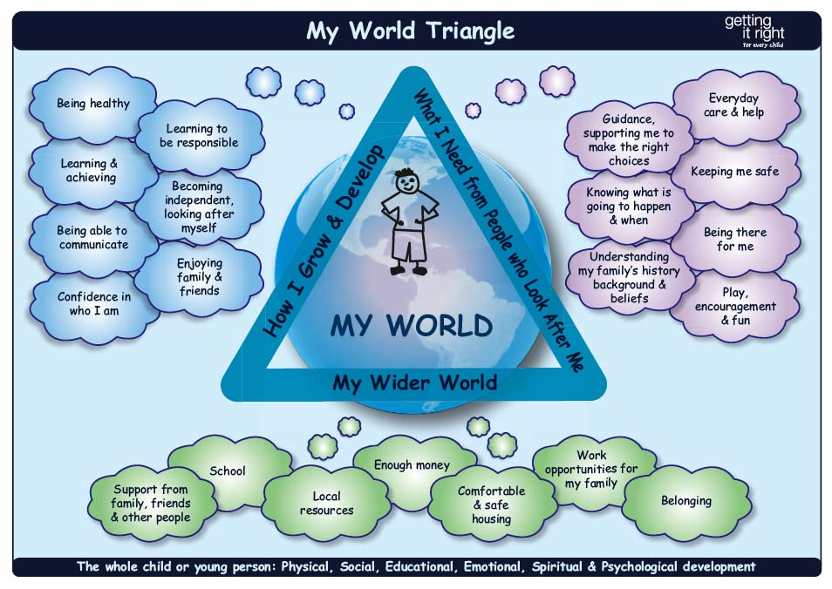

Using the My World Triangle allows practitioners to consider systematically:
- how the child or young person is growing and developing
- what the child or young person needs from the people who look after him or her
- the impact of the child or young person’s wider world of family, friends and community

We can then get a fuller picture of the help and support a child needs

Disguised Compliance
Disguised compliance is when a parent or carer appears to cooperate with professionals but does not take meaningful action to promote a child's welfare. It can happen when parents or carers:
• Are unaware of what is happening in their child's life
• Want to avoid raising suspicions
• Want to allay professional concerns
• Want to weaken professional intervention
Some signs of disguised compliance include: Inconsistent progress, Over-eagerness to please, Reliance on short-term fixes, Vague or shifting narratives, and Reluctance to engage in long-term planning.
It's important for you to recognize disguised compliance and know what actions to take when it's suspected

Children with Disabilities/Additional Learning Needs (ALN)
We recognize that statistically children with disabilities and additional learning needs are more vulnerable to abuse. We will ensure that team members who care for children with profound and multiple disabilities, sensory impairment and/or emotional and behavior problems know that they need to be particularly alert to signs of abuse.

Team members need to have a high level of awareness with learners who have ALN and promote a culture where they can make wishes and feelings known in respect of their care and treatment. All children with ALN should know how to raise concerns if they are worried or angry about something and should have access to a range of adults with whom they can communicate. Children with communication difficulties should always have available to them a means of being heard.

Prevent Duty policy statement
“Prevent Duty”, enforced in July 2015 under Section 26 of the Counter-Terrorism and Security Act 2015 requires Nurseries to do more to combat radicalization.
This means that child care practitioners (as part of our wider safeguarding duties) must be able to identify children, families and members of our own team who could be vulnerable to radicalization.

Radicalization simply means the process where someone is led to adopt extreme political, social and religious ideals and aspirations, basically opposite to the traditional values we aim to embed in our everyday work. The values being:

Democracy - a situation where everyone is treated equally and has equal rights. E.g. we have just one cardboard box and two explorers who want it for their rocket. Who goes first? What will we each do while we're in the box and out of the box?
Rule of law - learning to manage our own feelings and behaviour: about learning right from wrong: about behaving within agreed and clearly defined boundaries: about dealing with the consequences.
Individual liberty -We help children to develop a positive sense of themselves. Every time we provide opportunities for children to gather wild flowers, mix their own colours for leaf painting or take part in a game, we are helping them to develop their self-knowledge, self-esteem and increase their confidence in their own abilities. Every time we share a favourite book with a child, splash in rock pools or build a compound for our dinosaurs together we are giving children the time and space to explore the language of feelings and responsibility; reflect on their differences and understand that we are all free to have different opinions.
Mutual respect and tolerance for those with different faiths - where we learn to treat others as we want to be treated, how to be part of a community, manage our feelings and behaviour; and form relationships with others. Naturally we should have an ethos of inclusivity and tolerance in our settings, where views, faiths, cultures and races are valued and where we encourage children to engage with their wider community. It is our job to help children to appreciate and respect their own culture and the culture of others.
We can help them explore similarities and differences between themselves and others; among families, faiths, communities, cultures and traditions; and to share and discuss practices, celebrations and experiences. After all, if children see and hear the adults they love respecting other cultures, religions and values then this will have a significant, positive impact upon their own behaviour and overall development.

But being good role models isn't quite enough.
This means that for children to truly learn the importance of tolerance, they need to be given lots of opportunities to practice tolerance and to challenge stereotypes. For example, through sharing stories that reflect and value the diversity of children’s experiences and providing resources and activities that challenge gender, cultural and racial stereotyping.

This doesn’t mean putting out the odd multicultural jigsaw or doll here – it’s having an accessible and continuous provision of a diverse range of musical instruments - everything from djembes to kotos to manjeeras. Or junk modelling materials to make anything from Native American dreamcatchers to Anansi spiders to Gwiazdy stars, or lengths of fabric that can be saris just as easily as they can be superhero capes or Roman togas. If what we bring to the setting is diverse, then so will the children's experiences of the world and the people around them.

Practice and Procedure
So, everything a child says or does is learnt from their surroundings. They might be speaking words they don’t understand but preschoolers will believe whatever adults say. Our role means we are in a position through the promotion of positive experiences to show them the different people and cultures of the world and to teach them tolerance.

So protecting children from the risk of radicalisation should be seen as part of childcare practitioners wider safeguarding duties, and is similar in nature to protecting children from drugs, gangs, neglect, religion, sexual exploitation etc., whether these come from within their family or are the product of outside influences.

There is no single way of identifying an individual who is likely to be susceptible to a Terrorist ideology. More often than not, terrorists became that way unknown by the family that surrounded them so it’s not easy to pin point someone going down that path. At the same time we should be aware of the increased risk of online radicalisation, as terrorist organisations such as IS/ISIS/DASH seek to radicalise young people through the use of social media and the internet. People are vulnerable to becoming involved in terrorism can be any age, from any group, faith, ethnicity or background. Radicalisation doesn’t happen overnight, it’s a gradual process that takes place over time, which is why if you are aware you can stop them heading in that direction.

However as with any safeguarding issue, here are some pointers to look for (and this bears relation to the child and family members). Always remember that some children simply come from a racist background so don’t jump to conclusions, but refer it on to your manager for advice:
- Have they made negative comments about faith, religion or culture?
- Has the child become withdrawn or aggressive in a way they weren’t before.
- Maybe they tell you they have been watching jihadist videos online and talking of going to “help”
- When you talk to the parents, are there issues at home. Has dad left, how much time is spent online?

See separate Prevent Duty sheet for case studies

Procedure for reporting concerns
If a team member has a concern about a particular child they should follow the nurseries normal safeguarding procedures for reporting concerns.

Procedure for dealing with Parental complaints (whether raised voice or not)
Any parent raising a concern should be directed into the office for privacy. The hallway maybe clear when the conversation starts, but it rarely stays empty for long. In the unlikely event that a parent starts to act in an aggressive or abusive way at the nursery, the team member should direct the parent away from the children and into office. If the area is out of view, a second team member should be in attendance. The team member should act in a calm and professional way whilst encouraging the parent to calm down. Once the parent calms down, the team member should then listen to their concerns and respond appropriately.
Remember to keep your voice low at all times regardless of how loud they get. If you stay low, eventually they will become quieter too.
If you don’t have the answer, never feel pressured into giving them and answer and never say what you think happened. Explain to them that you have noted everything they have said and that you will get back to them as soon as you have asked the relevant people.

Some lines that can be used are :
- I appreciate your concerns, but aggressive/abusive language is not going to help rectify this.
- I really want to sort this out for you so if you just remain calm and explain to me exactly what the issues is, I know we can work together to sort this problem
- I am really sorry that this happened, but I will speak to the rest of the team when they are back in tomorrow and come back to you
- Please do not think I am dismissing your concerns but I don’t want to give you information that is not factual or is incomplete so let me speak to the rest of the team and I will get back to you by…….

Mobile phones and cameras
Mobile phones or smart watches with camera’s enabled are strictly prohibited from the children’s rooms and garden. Team members and visitors are required to keep their phones in their bags or lockers in the team rest. Photographs can only be taken by nursery cameras and tablets and must never be taken into toilets or changing areas. Parents are only permitted to take photographs at events once permission has been gained from all parents of children attending.

